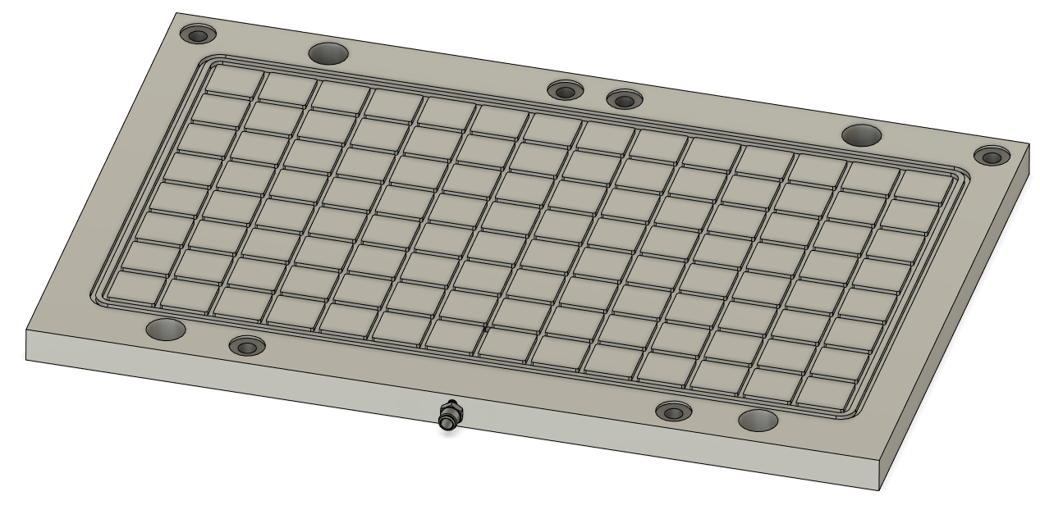
Vacuum Plate Tooling Usage Guide
The purpose of a vacuum plate is to hold large flat stock, or stock you need access to sides and top of part unimpeded.
- Treat the plate delicately, if damaged, bent, scraped, etc, the plate will not work as intended and you may be liable for damages
- Vacuum plate bolts directly into the Saunders Table Plate
- Always leave +.008” above the bottom of your part
  - If you plan to machine all the way to bottom edge of your part use a purpose built sacrificial top late. See how at piersonworkholding.com
- Always use gasket when holding you part
- For best tips and tricks look up Pierson Workholding Top Ten Tips
- Always use the coolant catch inline to prevent flooding vacuum source
- Make lighter cuts then you normally would as vacuum holding is more suspectable to lateral forces
- Sandwich some 600 grit sandpaper between your part and the top surface (grit side up) to increase lateral holding

To Set Up
- Remove all work holding from the bed
- Clean the bed thoroughly
- Make sure the vacuum plate is free and clear of chips
- Remove the necessary hole plugs from the Saunders Plate
- Bolt the vacuum plate down with 4 cap head bolts (~1” thread length)**
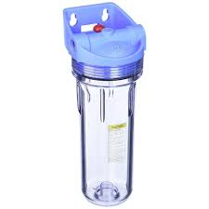
- Attach the inline coolant catch to the side of the machine with magnets
Figure 1 Coolant Catch
- Attach ¼” od hose from vacuum plate to coolant catch
  - Make sure air flow will be in proper direction (look at arrow on top of coolant catch)
- Attach Vacuum gauge inline (recommended between pump and coolant catch, not between coolant catch and table)
- Attach line to vacuum source (vacuum pump or venturi)
- Use ¼” gasket cord around the largest area possible to hold your part
  - Do not stretch cord while installing
  - Cut ends square
  - Do not glue ends
  - Meet ends in a enclosed row
  - Always make sure to position so your part and vacuum ring is around the vacuum hole
  - Do not use o-ring or nitrile cord, use only gasket cord.
- Place part and turn on vacuum, you want at least 25hg vacuum holding force
- Continue to set up as you normally would

